Ideation Phase
Brainstorm & Idea Prioritization Template

Date | 20 February 2026
Team ID | LTVIP2026TMIDS79232
Project Name | Booknest: Where Stories Nestle
Maximum Marks | 4 Marks

Brainstorm & Idea Prioritization Template:
Brainstorming fosters an open and inclusive environment where every team member is encouraged to actively engage in creative thinking to drive problem-solving. Emphasizing the generation of a large volume of ideas over immediate value, this process welcomes unconventional and innovative thoughts. Team members are inspired to build on one another’s suggestions, promoting collaboration and the development of a diverse pool of creative solutions.
Step-1: Team Gathering, Collaboration and Select the Problem Statement
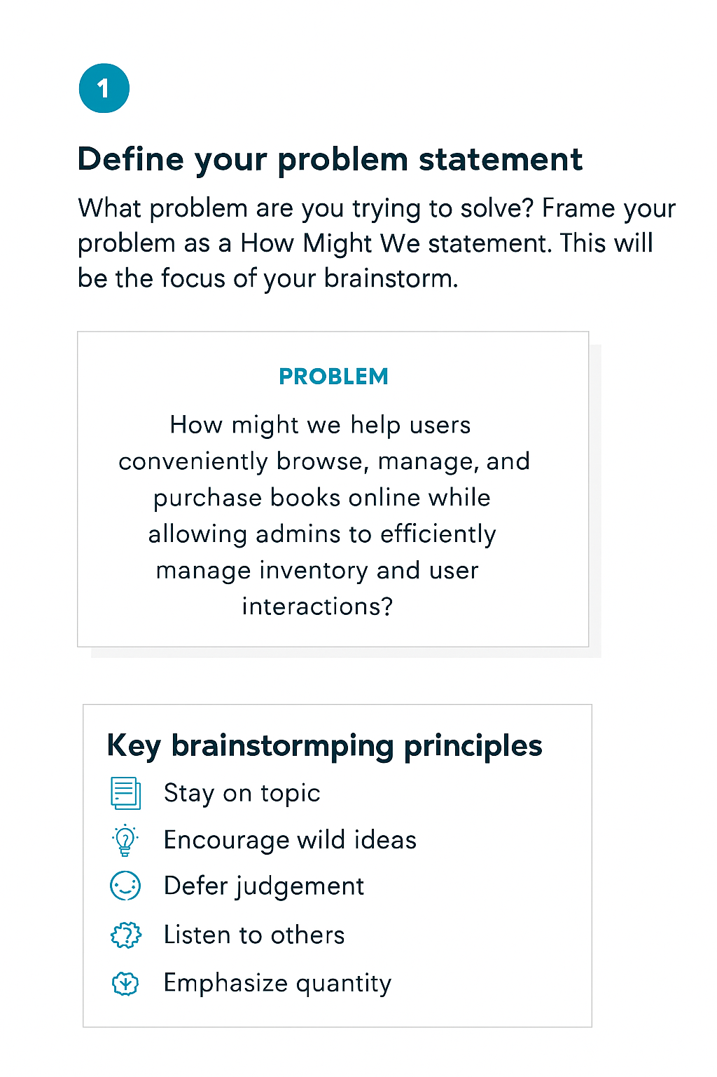

Step-2: Brainstorm, Idea Listing and Grouping

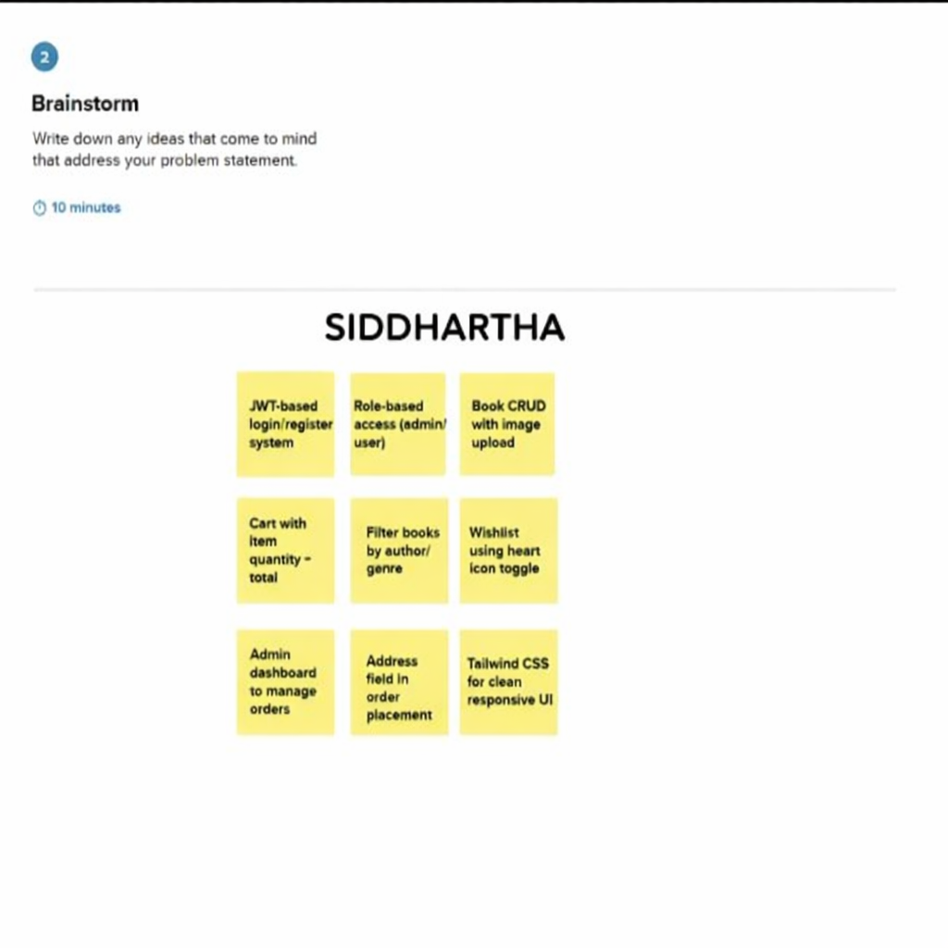

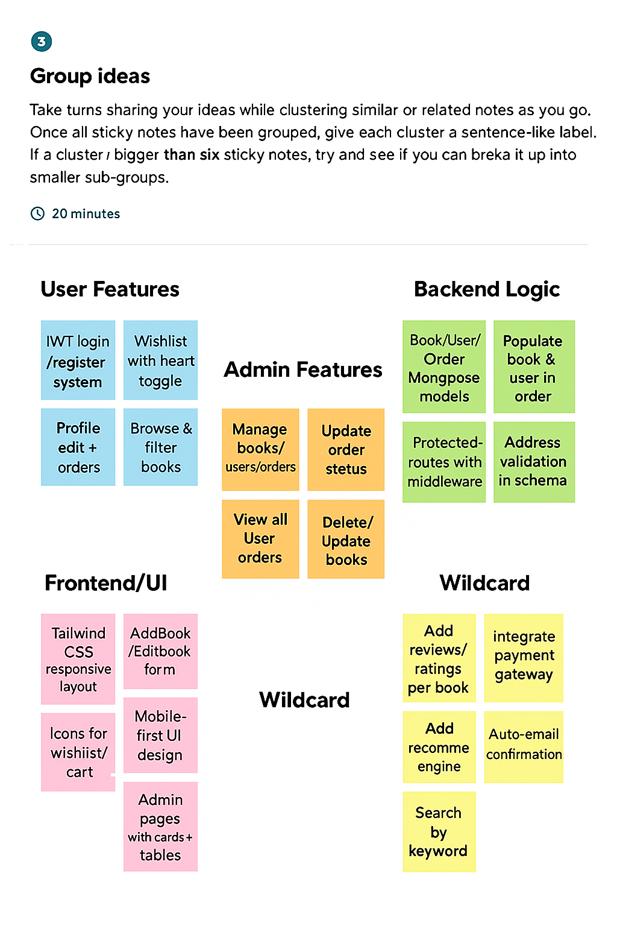

Step-3: Idea Prioritization
